**Flutter Application for Desktop, Android and iOS.**

**By Colt Coders** (Jayesh, Harsh)

**Documentations**

**Summary:**

To get ease for payment process we made this Cross Platform Software ‘Mi Payments’. This Software is for Store Venders to make every transaction easy to make and easy to maintain. This software is developed using Dart language and Flutter framework. Software UI is easy to navigate and easy to access all the contains. Software contains three major sections to make transactions. And has drawer to navigate from one page to another.

Software is made for Desktop/MacOS/Android/iOS users. Software contains Select Items Page for select items and add card, similarly once items has been selected, they can proceed with continue button. Fill Details page contains the necessary fields which must be filled to proceed for payment. Once every field is filled, we can proceed by clicking on Proceed Button. Once you click on Proceed button, it will pop up a notification which indicates the purchase status and now you can go to Orders Section to see all previous Orders along with order details.

The Software is capable of work locally in a system. Software is not capable to give PDF invoice and Email, WhatsApp Payment Conformation message feature due to time constraints. Software is will not store all data locally, it will start as fresh installed software after every new window opens. Due to working with many different Machines with single codebase, it is possible to upgrade the Software with more details and efficiency.

**Work Flow:**

The work flow of Software is very simple and easy to understand.

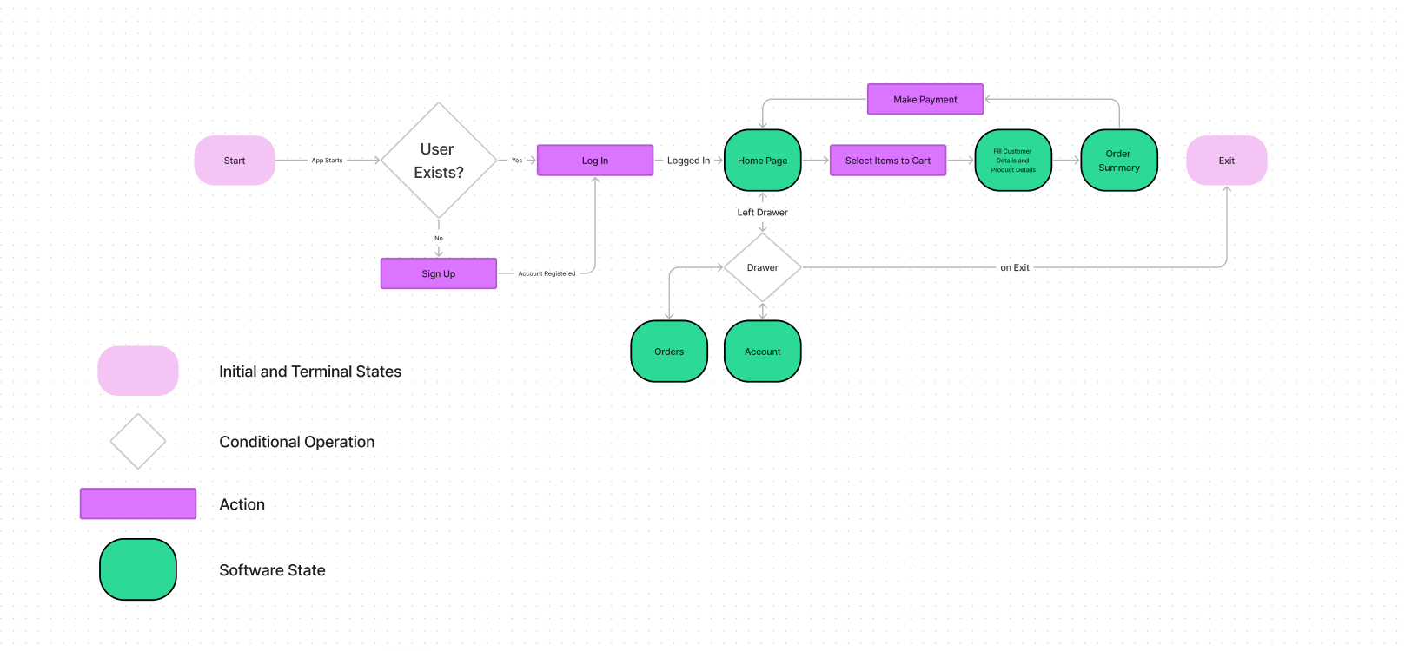

Can Refer more about each Section in [Github](https://github.com/JayeshHadke/Mi-Hackathon) .

**Language & Other Components Used:**

Flutter, Dart, Kotlin, Objective C, Figma.

**Installation:**

**Android:**

1. Get .apk file from installers/Android/ folder.
2. Get the apk file in any android device (must be Android 6.0 or more).
3. Tap on apk file and install it by pressing install button in dialog box.
4. After installation click on Open button to enter into app.

**Desktop:**

1. Get .exe file from installers/Desktop/ folder.
2. Double click or right click on Mi Payments software and click install.
3. Click next until you get installation progress bar.
4. Once Installation done, open the Software by Windows search or by clicking on Shortcut which has been created on Desktop.

**Team Details and Roles:**

* Jayesh Hadke ([LinkedIn](http://www.linkedin.com/in/jayesh-hadke-a77a081b1), [Hackerearth](https://www.hackerearth.com/@jayeshhadkejrh), [Github](https://github.com/JayeshHadke), Hackerrank)
  + Team Leader
  + Frontend and Backend Developer
* Harsh Kumar Yadaw (LinkedIn, [Hackerearth](https://www.hackerearth.com/@harshky24), [Github](https://github.com/harshky23))
  + UI/UX Designer
  + Frontend Developer